**What you always wanted to know about secondary psychiatric impairment\***

\***but were afraid to ask**

**First** – **a brief survey of workers compensation**

In 2050 B.C., ancient Sumerian law provided compensation for an injury to a worker’s specific body parts, for example, the loss of a thumb was worth twice the value of loss of a finger.

 Ancient Greek, Roman, and Chinese laws

* similar systems of compensation specific maimed parts.
* distinction between impairments (the loss of function of a body part) and disabilities (the loss of ability to perform certain tasks) still in workers’ compensation laws today.

Industrial revolution vastly increased the extent/ rate of work injuries. Employers could be sued but not if:

* there was contributory negligence
* the injury was caused by a co-worker
* the employee had assumed risk when signing a contract

German Chancellor Von Bismarck introduced workers’ compensation in 1884

Victorian Employers’ Liability Act 1886 abolished defence of 3 reasons above

Australian legislation – workers’ compensation

SA Workmen’s Compensation Act 1900

WA Workers’ Compensation Act 1902

Qld Workers’ Compensation Act 1905

NSW Workmen’s Compensation Act 1910

Tasmania Workers’ Compensation Act 1910

Commonwealth Workers’ Compensation Act 1912

**Victoria Workers’ Compensation Act 1914**

NT Workmen’s Compensation Act 1920

ACT Workmen’s Compensation Ordinance 1951

**Victorian Workers’ Compensation Laws**

The *Workers’ Compensation Act 1914* (modelled on UK *Workmen’s Compensation Act 1906*)

The first ‘no fault’ statutory benefits scheme.

This scheme paid benefits for injuries "arising out of **and** in the course of employment" and operated concurrently with the right to sue.

Workers had to choose whether to receive statutory benefits or make a common law claim.

Table of Maims in 1915 amendment that continued almost unchanged until 1985

In 1948 ‘no fault’ extended to injuries " arising out of **or** in the course of employment".

1970s Problems:

* work accidents common
* no incentives for employers to provide safer work
* weekly payments terminated after fixed period - unfair to workers with no work capacity
* lump sum payments inadequate
* common law delays – incentives to stay injured

**A brief comment on the Table of Maims**

The Table of Maims was a list of various injuries with a percentage of the total amount of compensation

The 1914 Act provided a rudimentary Table of Maims.

*Special provision is made for the payment of a lump sum ranging from 5% to 100% of £500 in respect of total incapacity where the accident results in loss of a member, or of hearing, or of sight in one or both eyes.*

Table of Maims introduced in the Workers’ Compensation Act 1915 e.g.:

*Total loss of the sight of both eyes 100%*

*Total loss of a foot 65%*

and

* *Total and incurable loss of mental powers involving inability to work 100%*
* *Total and incurable paralysis of limbs or of mental powers 100%*

The latter 2 ‘maims’ was in the legislation in 1946, 1953, 1958, 1973 and 1975.

The Accident Compensation Act 1985 also included the Table of Maims (section 98) but the second of the 2 maims re psychiatric injury was changed to:

* *Total and incurable paralysis of mental powers 100%. (no-one knew what this meant)*

Psychiatrists were asked to comment on the percentage of

* *Total and incurable loss of mental powers involving inability to work*
* *Total and incurable of mental powers*

(later called section 98 claims). There was no method prescribed for determining this, it was a guess.

In 1992 legislation amended the Table of Maims

* *total and incurable loss of mental powers involving inability to work*
* *total and incurable paralysis of mental powers*

was substituted by:

* *Permanent brain damage 0-100% of $93 080*

An additional section was added –

* *98A Compensation for pain and suffering. “pain and suffering” meant-actual pain; or distress or anxiety*

The **Workplace Injury Rehabilitation and Compensation Act** (2013) replaced the Table of Maims with the No Disadvantage—Compensation Table listed in Schedule 4. Permanent brain damage and ’pain and suffering’ were excluded.

**Accident Compensation Act 1985**

ACA 1985 – now acknowledged as a well meaning disaster

workers got too much too soon and for too long – financial failure

The ACA 1985 introduced the American Medical Association Guides to the Evaluation of Permanent Impairment. This was the first use of the AMA Guides in Australia.

Chapter 12 Mental & Behavioral Disorders proved to be a major problem.

There was no method of combining scores and examples given were wrong. Impairment levels ranged from 5% to 60% for the same person. There was real concern that work related psychiatric injury would be excluded.

The User’s Manual was developed informally - the manual introduced the Median method and became the de facto standard, quickly impairment levels became more reliable. It is the basis of the GEPIC.

The Transport Accident Act 1986 was developed in conjunction with the ACA and lead to the formation of the Transport Accident Commission, it included:

* no-fault and access to common law.
* AMA 2 specified regarding impairment benefits

Medical Panels were set up in March 1990

The Government recognized 2 major problems with stress claims leading to a significant budget blowout.

1. Stress claims made because a worker did not get a promotion or expected benefit and
2. the so-called psych top-up where a worker could combine the percentage score from a physical injury with the score from the associated psychiatric impairment to reach or exceed the 30% threshold for a serious injury leading to long term benefits.

The first issue was dealt with in amendments in 1992. A new section was taken from Commonwealth legislation regarding ComCare:

S.82(2A).

*There is no entitlement to compensation in respect of an injury to a worker if the injury is a mental injury caused wholly or predominantly by any one or more of the following—*

*(a)* [*management action*](http://classic.austlii.edu.au/au/legis/vic/consol_act/aca1985204/s82.html#management_action) *taken on reasonable grounds and in a reasonable manner by or on behalf of the worker's employer; or*

*(b)     a decision of the worker's employer, on reasonable grounds, to take, or not to take any* [*management action*](http://classic.austlii.edu.au/au/legis/vic/consol_act/aca1985204/s82.html#management_action)*; or*

*(c)     any expectation by the worker that any* [*management action*](http://classic.austlii.edu.au/au/legis/vic/consol_act/aca1985204/s82.html#management_action) *would, or would not, be taken or a decision made to take, or not to take, any* [*management action*](http://classic.austlii.edu.au/au/legis/vic/consol_act/aca1985204/s82.html#management_action)*;*

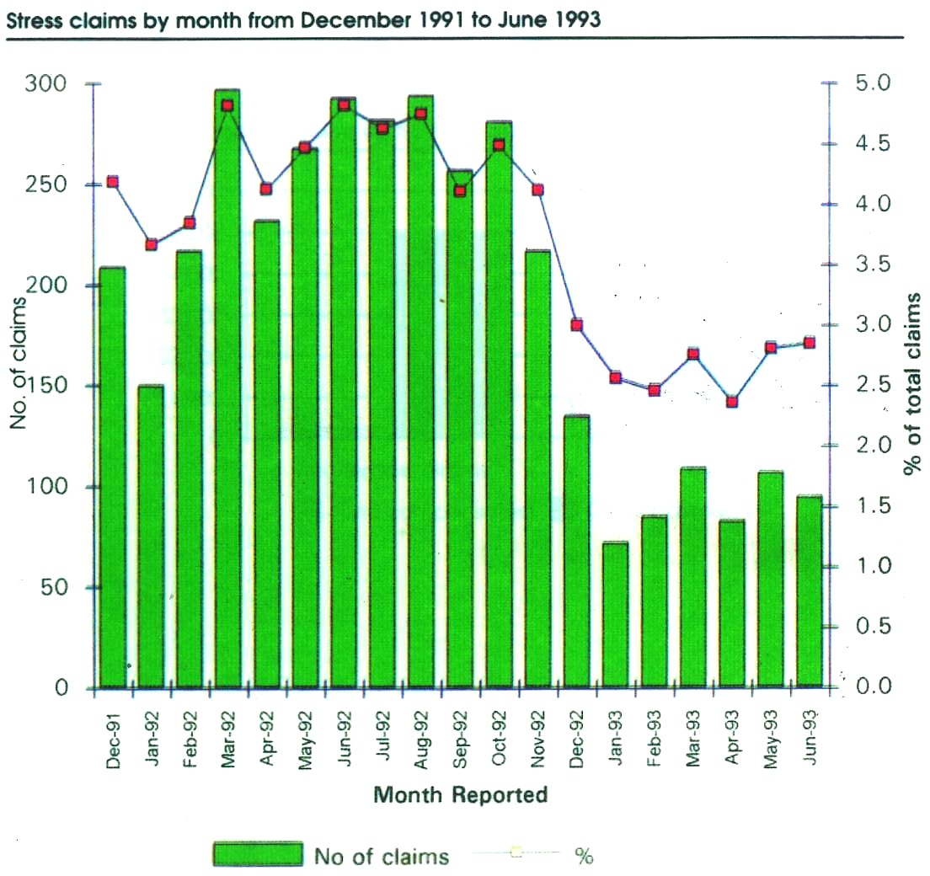

This graph illustrates the dramatic drop in the number of ‘stress’ claims both in overall terms and as a percentage of all claims. Ironically this proved to be a ‘paper tiger’. To my knowledge very few, if any claims were thrown out on this basis.

The second issue of the ‘psych top-up’ proved more intractable

Workers have a physical injury and become depressed. A back injury may lead to an impairment of 15%, the associated depression leads to a psychiatric impairment of 15% and the worker’s impairment has thus reached the 30% threshold for enduring payments and a common law claim.

**The Government’s Problem**

Serious injury claims went from 1 in 8 in 1993/4 to 1 in 4 in 1995/6 and were still rising.

The legal profession openly boasted that this was the loophole through which they get serious injury status for their clients.

In a survey of 300 claims, over 55% of workers with "serious injury" status after a psychiatric or psychological assessment had never had any psychological or psychiatric treatment, either before or after the assessment.

The financial impact of this loophole was in excess of $300 million.

**Introduction of Secondary and Non secondary psychiatric impairment**

This financial blowout lead to legislative action in 1996 by the Kennett Liberal government. There was no discussion with the RANZCP or the AMA. In late 1996 the government introduced amendments to the ACA 1985. Amongst the amendments was a new section:

*Section 92 (2)*

*In assessing a degree of impairment under sub-section (1) regard must not be had to any psychiatric or psychological injury, impairment or symptoms arising as a consequence or secondary to, a physical injury*

When introducing this section, the minister gave 4 examples of how this would work.

**Example 1**

* *worker suffers burns to the hands, face and legs from a workplace explosion.*
* *nightmares about the explosion*
* *cannot face returning to the accident site*
* *a fear of confined spaces.*

The minister said that the worker's psychiatric injury is a direct result of the explosion that caused the physical injuries and the psychiatric impairment.

He said: in that case the psychiatric impairment would be included in the worker's overall impairment assessment for the purposes of determining serious injury.

**Example 2**

* *worker's leg caught in machinery .worker is dragged toward the machine as the leg is crushed.*
* *the worker has a phobia relating to any machinery*
* *the worker relives the accident*

Minister: Any resultant psychiatric impairment would be included in the assessment of the worker.

He said ’In both the examples I have given the psychiatric component is not secondary or consequential to the injury. It is a direct result of the events or circumstances in the workplace that gave rise to the physical injury and as such would be included in determining the worker's impairment level’.

**Example 3**

* *Back injury at work, activities of daily living effected, depressed.*

The minister said that:

*The Physical impairment is 10 %, impairment from depression not included therefore no serious injury (impairment below 30%).*

*Eligible for payments if the secondary psychological condition* ***or*** *the physical injury meant unable to work.*

*The worker would receive benefits at 70 per cent of pre-injury earnings if classified as totally and permanently incapacitated.*

*Eligible for medical and like services*

*Compensation under the table of maims.*

*But no action against the employer at common law unless he qualified under the narrative safety net.*

**Example 4**

* *worker minor injury to finger of non-dominant hand. Effective treatment and function close to normal.*
* *The worker convinced hand no better and avoids all activity*
* *disuse atrophy of the hand and a chronic anxiety state.*

The minister said:

*impairment due to chronic anxiety excluded from worker's impairment*

*Anxiety state did not arise out of the circumstances that gave rise to the initial physical injury.*

**Commentary**

Examples 3 & 4 consistent with understanding of 2ndary impairment

By contrast, Examples 1 & 2 imply that **ALL** the psychiatric impairment from the work injury would be included. This is **not** our current understanding.

Now we would include impairment from PTSD and exclude impairment due to depression/anxiety from the physical injury!

Comments from the Labor Opposition

* *the legislation is reprehensible.(Mr Steve Bracks, future premier)*
* *It is as if under this regime one has to be without arms, without legs, and without any physical ability at all before one receives coverage under the Workcover scheme. .(Mr Steve Bracks, future premier)*
* *hasty, ill-considered and vicious legislation that concentrates on a financial bottom line rather than on caring for vulnerable people.*
* *an evil piece of legislation. It is evil because it does not even pretend to pass minimum standards of things like honesty.*
* *It is no more than a shabby attack on workers and it needs to be clearly exposed as such.*
* *It is one of the most evil measures that has been brought into this Parliament in my eight years as a member.*
* *The bill has no redeeming features whatsoever.*
* *The bill sets back not only the treatment of workers in this state but also the cause and treatment of the mentally ill as no other action has done in my time in Parliament.*
* *This is the most evil, pernicious and disgusting piece of legislation ever introduced in this house.*
* *It is so immoral that it is unbelievable.*
* *The government's discrimination against the mentally ill is second to none in any state in this country.*

The Accident Compensation (Amendment)Act 1996 was passed December 1996

Section 91(2) *In assessing a degree of impairment regard must not be had to any psychiatric or psychological injury, impairment or symptoms arising as a consequence of, or secondary to, a physical injury.*

Inserted into the Transport Accident Act 1997 Section S 46A

**Result**

There was widespread confusion for all. No one, including the courts, solicitors, barristers and psychiatrists knew how to apply this new section of the Act.

There were many newspaper articles about the perceived “injustices”.

One item claimed that a police officer who was shot at and developed PTSD would receive higher benefits than a police officer who was shot and wounded.

Confusion abounded!

How did I deal with this?

**My first response**

Follow the Minister’s first two examples:

For a worker or a transport accident victim who had both physical and psychiatric injuries from the same accident I assumed that the whole person impairment would be accepted.

Result: The courts took no notice of my explanation and told me I was wrong.

**Second response**

I iInterpreted the legislation strictly. In determining whole person impairment I took no notice of any impairment there was consequential or secondary to a physical injury.

Result:

*“Doctor, what is the claimant’s whole person psychiatric impairment?”*

*“I have already told you”.*

*“But you have only given us the impairment that is not secondary to physical injury!”*

*“But that is what I am required to do.”*

*“Doctor, I will ask you again, what is the claimant’s whole person impairment?”*

*“I did not determine the claimant’s impairment secondary to physical injury as I am not required to do so”.*

*“Doctor, for the third time what is the claimant’s whole person impairment?”*

In other words, my reading of the legislation was not regarded as correct.

**My third response**

I assumed that since the AMA Guides combined subsidiary impairments using a table, the same process should apply to combining secondary and non secondary psychiatric impairment.

So, more humiliation

*“The worker has a whole person psychiatric impairment of 20% and the impairment that is not secondary to physical injury is 15%”.*

*“So the impairment that is secondary to physical injury is 5%?”*

*“No, the standard practice of the AMA guides is that subsidiary impairments are combined. According to AMA 4, the combination of two subsidiary impairments of 10% is 19%. I have used the same logic with regard to these subsidiary impairments.”*

Not accepted.

**My fourth response**

I assumed that secondary and non-secondary psychiatric impairment were additive

determine whole person psychiatric impairment and impairment secondary to a physical injury, the remainder being impairment not secondary to physical injury. I finally got it right.

It reminded me of the Monty Python skit about the Piranha Brothers

*If you paid us protection we beat you up-*that didn’t work

*if you didn’t pay us protection we didn’t beat you up-*that didn’t work

*if you paid us protection we didn’t beat you up-*that worked!

Introduction of American Medical Association 4th edition

American Medical Association 4th edition published in 1993 introduced into Victoria in 1997

AMA Guides 4th edition would replace AMA2. Chapter 14 Mental and behavioral disorders included a Table.

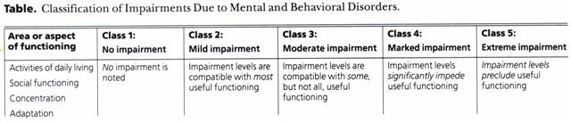 Section 98 (8) stated that the Reference to AMA Guides referred to the American Medical Associations’s Guides to the Evaluation of Permanent impairment (Fourth Edition).

**Two Problems with AMA4 Chapter 14**

1. 4 aspects of functioning - only one – Concentration, is a measure of Impairment, the other 3 are measures of Disability.
2. lack of any percentages.

**UNWORKABLE –**

What to do? In Victoria we chose to expand the User’s Guide and produced the Clinical Guide to the Rating of Psychiatric Impairment (CGRPI) gazetted in October 1997.

In 1999 NSW also decided to use AMA4. There was recognition in NSW of the problems with Chapter 14.

Nigel Strauss and I gave a presentation about the Clinical Guide to the Rating of Psychiatric Impairment to a representative group of NSW psychiatrists.

They ignored our work and developed their own guide based on AMA 4 -The Psychiatric Impairment Rating Scale (PIRS). PIRS is a measure of disability and not impairment. NSW, Qld, WA, NT and Tasmania also began using AMA 4 or 5 and since the PIRS is an expansion of Chapter 14 it was also used, most use a variation of the NSW Workers Compensation Guidelines for the Evaluation of Permanent Impairment.

The concept of secondary psychiatric impairment spread to all states and territories except the Northern Territory and the Commonwealth, the ComCare Guides.

In NSW, WA, Qld and Tasmania it was called Primary and Secondary Psychiatric Impairment.

The Victorian Wrongs Act (1958) was amended in 2003 so that a claim could not proceed unless the physical impairment was 5% or more using AMA 4 and the psychiatric impairment was more than 10% according to the GEPIC.

The ACA was replaced by the Workplace, Injury, Rehabilitation and Compensation Act in 2013 (WIRCA (2013) and Section 91(2) became Section 56.

In 2013 South Australia implemented a new Workers’ Compensation and Motor Accident Act that used AMA5 and the GEPIC South Australia also implemented the notion of secondary and non secondary psychiatric impairment but called it ‘Pure Mental Harm’ and Consequential Mental Harm’..

**Irony**

The Labor opposition has been in power for 20 of the last 30 years. Despite their cries of apocalypse they have never sought to rescind Section 92A (now WIRCA S 56)!

**GEPIC**

Opportunity for an amended version of the CGRPI arose in 2005.

The major changes were:

* removal of some outmoded language such as “retarded”
* extra descriptors regarding both aggressive and withdrawn behaviour
* a change to the wording with regard to Mood to make it less restrictive.

These changes were incorporated into the new version renamed

The Guide to the Evaluation of Psychiatric Impairment for Clinicians (GEPIC)

Gazetted on 27 July 2006 and incorporated into subsequent legislation replacing Chapter 14 of the 4th edition of the AMA Guides.

Nigel Strauss and myself have trained 140 psychiatrists in use of the GEPIC

**Workers Compensation issues continue - Plus ca change etc.**

The Report of the Victorian Ombudsman-2020 Follow-Up Investigation into the Management of Complex Workers Compensation Claims is a follow-up investigation to the report published in 2016 and the further report in 2019.

The concerns about Claims Agent selecting ‘hired guns’ lead to centralization of Psychiatric IME bookings

The most recent Ombudsman’s report discusses appointments of IMEs, feedback regarding the new selection criteria, quality assurance issues and changes since the 2016 investigation.

Concern about the lack of availability of Psychiatrist IMEs lead to a 25% increase in fees in April 2019.

There are continuing concerns that WorkSafe do not acknowledge that the skill set required of an IME is additional to the generic skills of medical specialists and general practitioners.

The assumption is that IMEs can perform the tasks required without additional training. This leads to inadequate reports and an apparent vacuum with regard to measures to improve quality. The assumption made by WorkSafe is that their selection criteria, induction and service standards are adequate.

**The Most Recent Activity**

An Independent Review regarding options for changing the current agent model regarding the management of complex claims arose out of the Ombudsman’s report.

The Options paper was release in 12/2020 with written comments to be made by 29 January 2021.

1. Option 1 is the baseline option. All workers’ compensation claims, whether ‘complex’ or otherwise, would continue to be managed as they currently are using the outsourced ‘agent model’.
2. Option 2 would require each agent to establish a dedicated complex claims unit to manage complex claims.
3. Option 3 would require WorkSafe to appoint a single, specialised agent to manage complex claims.
4. Option 4 would require WorkSafe to establish a dedicated complex claims unit within WorkSafe to manage complex claims. Claims would be triaged by agents.
5. Option 5 would also require WorkSafe to establish a dedicated complex claims unit within WorkSafe to manage complex claims. Claims would be triaged by WorkSafe.
6. Option 6 would introduce a hybrid claims management model between WorkSafe and agents with an increased decision-making and oversight function for WorkSafe.
7. Option 7 would abolish the ‘agent model’, with all claims (including complex claims) managed directly by WorkSafe.

**Challenges**

Fashions in Claims

RSI , in 1985/86 there were 7890 claims compared to 616 claims for RSI in 1994/95.

Stress now second highest cause of claims

Bullying up to 40 % of claims

Concerns re ‘hired guns’

The dominance of the Medical Agencies and concerns over independence.

No improvement in Return to Work rate

Need for RANZCP Section of Civil Assessment Psychiatry